**PAI LAB 4**

**Task 1:**

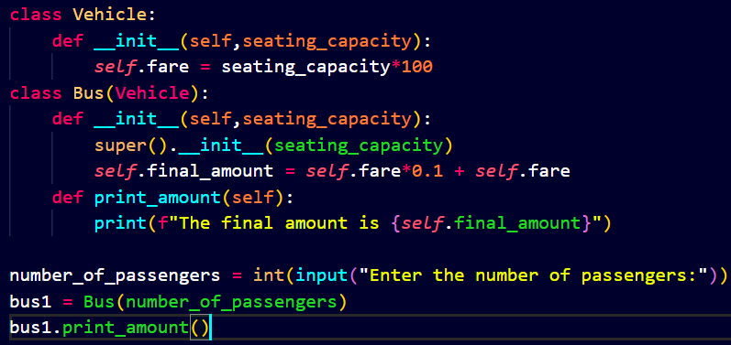

**Output:**

**Task 2:**

**Output:**

**Task 3:**

**Output:**

**Task 4:**

**Output:**

**Task 5:**

**Output:**

**Task 6:**

**Output:**

